Cam1 settings

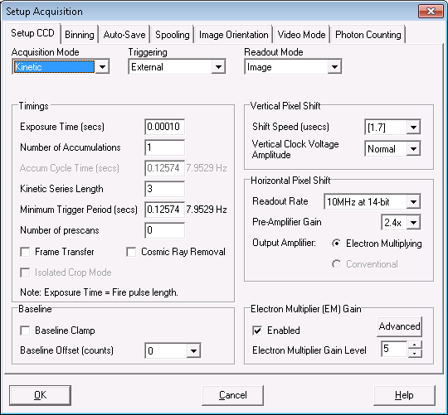

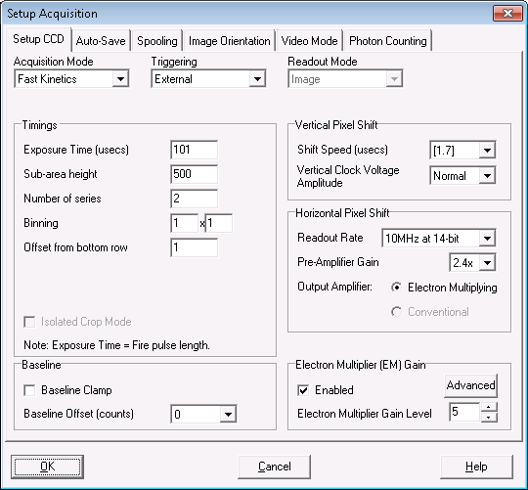

Exposure time changed to 40us on 9/25/17

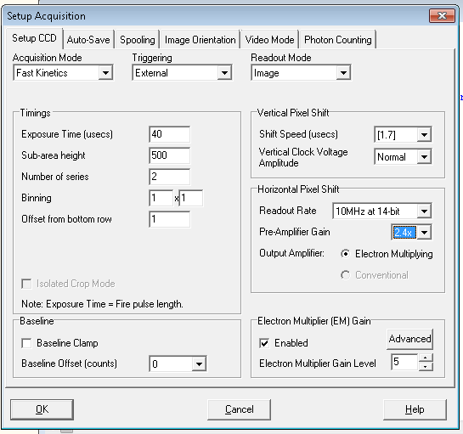

4/26/18

EM gain higher for -7/2 imaging

Baseline clamp enabled: <http://www.andor.com/learning-academy/quantitative-stability-stability-in-emccds>

Preamp gain 4.9x

